# VET ADVISOR RECRUITMENT FORM LETTER

This form letter can provide you with a starting point for recruiting organizations to share data with you in ZIMS for Medical.  
  
Dear_________,    
   
I, ________, the vet advisor for ____ and am reaching out to you with a new process that will help me review the relevant medical data for the population, and reduce the number of SSP vet advisor surveys you have to complete.

**Species360 has created a secure way to share data with a new institution category “Global/Regional Consortium”**. This institution category does not hold or own any animals but is used to view information on animals or species voluntarily shared with the institution.

 Vet Advisor institutions approved by the Regional Associations have been set up to allow **Species360 Members to voluntarily share their data directly with the vet advisor for the species/program**. Members maintain control of their level of sharing and can choose to share, or stop sharing, at any time. **The ownership of the data will stay with the institution entering the data, and the vet advisor will only have read-only rights to the shared data and must adhere to ZIMS data sharing and Regional Association confidentiality protocols. Vet advisors who are no longer in their role will have their ZIMS access deactivated by the Regional Associations.**

This concept has been tested within the community with the Vet Advisor Data Sharing Pilot project and is already in active use by the EAZA Biobank. Members using this new way of sharing have found it to be useful and had trust and confidence in the concept.

You can participate and share your data with the vet advisor institution by choosing to either share the data for the entire species or share the data for specific individuals. Sharing data for all ______ is the least amount of effort on your part, as you will only need to create the external sharing record once, and then all new births and acquisitions for _______ will be automatically shared with the vet advisor institution. If you choose to share specific individuals, you will need to enable sharing for each animal record separately, and I ask that you enable sharing for new births/acquisitions to keep the data set as current as possible.

I have included some instructions from Species360 below for how to share records for a taxonomy or specific animal. I have also included Species360’s instructions on how to search for all the program animals in your collection should you wish to set up external sharing for all vet advisors without waiting for them to reach out to you. You can also preemptively share your data with a vet advisor institution that has not yet had a vet advisor assigned or the role is vacant, your data is still secure and will be available to the vet advisor as soon as they are assigned.

**Species360 has created a secure way to share data with a new institution category “Global/Regional Consortium”**. This institution category does not hold or own any animals but is used to view information on animals or species voluntarily shared with the institution.

## Topics Covered

## Getting Started

How to Share with Vet Advisors

Finding All Vet Advisor Programs

## Contact [support@Species360.org](mailto:support@Species360.org)

## Getting Started

Vet Advisor institutions approved by the Regional Associations have been set up to allow **Species360 Members to voluntarily share their data directly with the vet advisor for the species/program**. Members maintain control of their level of sharing and can choose to share, or stop sharing, at any time. **The ownership of the data will stay with the institution entering the data, and the vet advisor will only have read-only rights to the shared data and must adhere to ZIMS data sharing and Regional Association confidentiality protocols. Vet advisors who are no longer in their role will have their ZIMS access deactivated by the Regional Associations.**

This concept has been tested within the community with the Vet Advisor Data Sharing Pilot project and is already in active use by the EAZA Biobank. Members using this new way of sharing have found it to be useful and had trust and confidence in the concept.

You can participate and share your data with the vet advisor institution by choosing to either share the data for the entire species or share the data for specific individuals. Sharing data for an entire species/programis the least amount of effort on your part, as you will only need to create the external sharing record once, and then all new births and acquisitions for the **species/program** will be automatically shared with the vet advisor institution. If you choose to share specific individuals, you will need to enable sharing for each animal record separately, and you will need to enable sharing for new births/acquisitions to keep the data set as current as possible.

## Back to Topics Covered

## How to Share

A single animal or an entire taxonomy can be shared from My Institution (Start>Institution>My Institution) in the External Sharing grid. To share a new animal or taxonomy, click Actions > Add New

1. Select the institution you want to share records with by entering the mnemonic for that species' program. For example, "Lynxsspva" for the Canada Lynx program.

If you need to find a program mnemonic, use the following steps:

Start> Institution> Institution Search> Enter Program name in the Search box in top left-hand corner.

For example: Canada lynx = LYNXSSPVA

1. Select the Taxonomy radio button to share records for an entire taxonomic group.
2. Type in the taxonomy of the species, "Canada lynx" in our example. Or you can instead check the "Animal" radio button to only select one animal's record, not all animals held of that species/group, and enter that animal's GAN #.
3. Then click "Next.

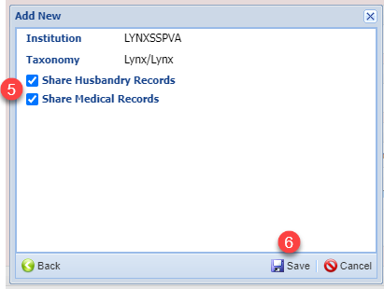

1. Choose whether you want to share your Husbandry and/or Medical records (both are recommended). (Note, you will need to have the correct roles to perform these actions, e.g., Local Admin to share husbandry records and Medical Admin to share medical records or custom roles)
2. Click Save.

The sharing will appear in the External Sharing grid for the animal record and My Institution.

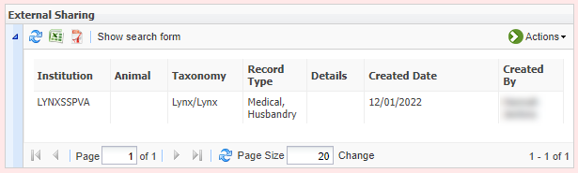

You can also share a single animal record from within the animal record Details tab in the External Sharing grid (Start>Animals>Search>Open Record>Bottom of Details tab). To share a record, click Actions > Add New

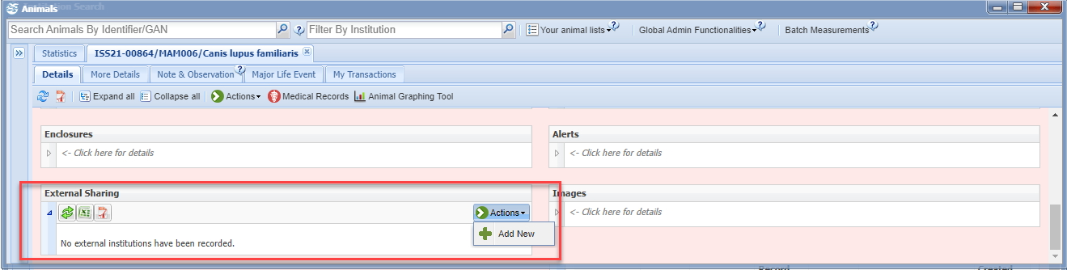

As you have already specified the animal, you will only need to choose which institution to share the record with "by typing in the vet advisor institution mnemonic associated with that species. For example, again we have chosen “Lynxsspva” for the Canada Lynx program.

You will only need to choose which institution to share the record with, and whether to share Husbandry records, Medical Records, or both.

You will need to repeat this step for all animals you wish to share and for any new births and acquisitions.

## Back to Topics Covered

## How to Search for All Vet Advisor Programs

**From Institution Search**

In ZIMS (Start>Institution> Institution Search) you can search by:

1. 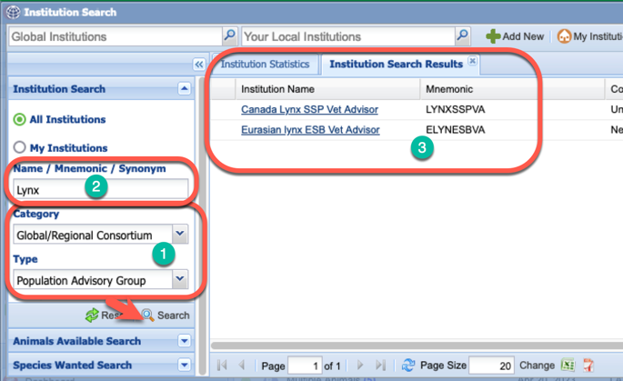Category Type = Global/Regional Consortium and Type = Population Advisory Group
2. To limit the results, you can try to add a species name, for example, Lynx,
3. Then Search for matching vet advisory results – these are the ‘institutions’ that you are sharing your records with – regional/global vet advisors are provided accounts at these special institutions to conduct their consultancy data reviews.

**From the Global Studbook Search Tool**   
  
This tool allows you to search for species you hold in specific studbooks. Only Studbooks currently managed in ZIMS for Studbooks will be found.

The tool is accessed from the start menu under Global Resources > Animal Management/Husbandry > Global Studbook Search Tool (you must have access to this Tool through your Role).

To search for species you hold in specific studbooks, you will use the “Taxonomy Held By” and “Scope” filters.

1. In the Taxonomy Held By box – type your institution.
2. In the Scope box – type in the Regional Association you are a part of (e.g., AZA to search all SSPs)
3. Click Search
4. You will now see a list of all the species you hold which are part of a studbook (within the Regional Association you searched).

You can now use this list to set up external sharing with all the species.

## Back to Topics Covered

***Revised 7 June 2023***